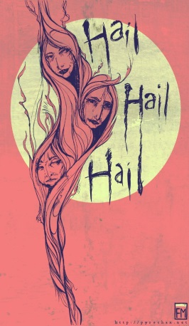
Macbeth- Scene 1.3-1.4 “Is Execution Done on Cawdor?”
Once again, the Weird sisters appear in a deserted field. Macbeth and Banquo will also shortly appear. Apparently, the witches have been waiting for them.
- On the line below, write the first words that Macbeth speaks. So foul and fair a day I have not seen.
- You heard similar words spoken earlier in the play. On the line below, tell who spoke those similar words and what did they say? The witches say “Fair is foul and foul is fair”. The witches say this at the beginning. Note the audience will know this and will link Macbeth to the witches.
- When Macbeth orders the witches to speak, they address him by three different titles. What are they? Thane of Glamis, Thane of Cawdor, King hereafter
- Describe Macbeth’s reaction when he first hears the witch’s predictions for his future. Incredulous and disbelieving (why do you dress me in borrowed robes?) but then almost curious.
- Why is Banquo suddenly fearful after Ross’ announcement? The witches prophecies are coming true!
- Now Macbeth is both frightened and confused because he faces a hard choice. He can either let chance make him king (he is of royal blood and could be elected in the future) or take matters into his own hands “My thought, whose murder yet is but fantastical.. (I, iii, 139)
Famous Quotes- in your own words, explain what this quote means (paraphrase)
Macbeth- “The Thane of Cawdor lives. Why do you dress me in borrowed robes?” (line 108-110)
Why are telling me I am the Thane of Cawdor when the Thane is alive, wearing his robes?

Scene 1.4
To the sound of the trumpets, the King, his sons and his nobles enter the castle at Forres.
- Did the Thane of Cawdor die bravely or cowardly? Explain your reasoning. He died bravely- he admitted his guilt and begged pardon.
- What role does Malcolm (Duncan’s son) play in the future of Scotland?) Malcolm is named the heir to the throne.
- Macbeth seems upset by the new honors given to Malcolm. Explain what Macbeth means when he says he must “leap over this new step”. Realizes he needs to take matters into his own hands and MAKE it happen as chance is not an option anymore.
Quotes- put in your own words and explain the meaning
Duncan- “There’s no art to find the mind’s construction in the face; He was a gentleman on whom I built an absolute trust.” (11-13)
It is hard to get an understanding of how someone feels about you based on how they act towards you. Sometimes they act loyal but are not loyal.
Macbeth- “Stars, hide your fires! Let not light see my black and deep desires” (line 50-51)
His ambition is “lighting up” behind his eyes, his desire to be king is shining through. He needs to compose himself and not show any sign of his ambition.

