“Dating Profile”

Tsar Nicholas

Setting up your profile:

What’s your full name: Tsar Nicholas
Hight: 1.7m
Age: 50
Relation Ship status: Married
Do you have any kids: 5
Do you want kids: no
What is your education level: PHD
Do you smoke: no
How often do you drink: never
What is your salary: 25000
What are your Interests: being a leader
Are you looking for something specific: nope

Tell us about yourself by writing an essay:

I like to take leadership and buy a whole bunch of land and put it to good use. I like taking control and having a lot of fun. I love talking about politics and I enjoy hanging out with my kids while teaching them how to become a leader. I have a couple dogs that my kids love to play with. My favorite thing to do in my free time is ruling people and bossing them around.

Tsar Nicholas II

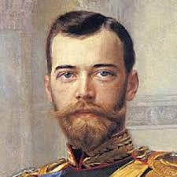

Hi, I’m Tsar Nicholas II and I am 50 years old, I have 5 kids and I don’t smoke. I have a PHD and I’m 5.5. I like to take leadership and buy a whole bunch of land and put it to good use. I like taking control and having a lot of fun. I love talking about politics and I enjoy hanging out with my kids while teaching them how to become a leader. I have a couple dogs that my kids love to play with. My favorite thing to do in my free time is ruling people and bossing them around.

