Digital Literacy 10 Mr. Aitken and Mr. Castonguay
Adding Reflections to Your Blog
Reflecting on your learning and progress is one of the key components to being a successful and life-long learner. As you move through Digital Literacy 10 and establish your portfolio it is important that you take the time, and reflect on your learning in relation to the various projects that you complete in your core courses and explorations.
What are the Core Competencies?
The core competencies are a method of reflecting on the development of your own skills and abilities. The information below will briefly introduce you to each of the six core competencies.

Communication
• Sharing ideas and showing your learning
• Learning new programs and apps

Critical Thinking
• Making reasoned and ethical judgements
• Assessing sources of information
Creative Thinking
• Creating new ideas, inventions, pieces of art, or other creative artifacts

Positive Personal and Cultural Identity
• Learning about yourself, your family, your culture or heritage
Personal Awareness and Responsibility
• Managing stress / Regulating emotions
• Setting goals
• Organizing your life
• Staying healthy and active
• Respecting your own rights and the rights of others
Social Responsibility
• Contributing to the well-being of your family, community, society, or environment
• Understanding other people’s perspectives
• Creating and maintaining healthy relationships

Adding Your Core Competency Reflections
It is expected that all students – regardless of whether they are in grade nine or ten will continue to add reflections, based around the core competencies, to their assignments.
To that end we have simplified the process for this year. Students now have access to a series of six documents (one for each of the core competencies) that they are able to access and edit in order to post the reflections to their blogs. The documents can be accessed and downloaded HERE. At present you will need to have MS WORD installed on your computer to utilize these. You can download it free from Office 365.
Each document looks similar to this one and can be altered to you to reflect on more than one core competency if necessary.
There is a brief synopsis of the traits of the core competency. Use these to develop a thoughtful reflection on your work.
At the bottom of the page is a section where you can discuss where you plan to go from here and how you can develop and improve further.

Once you have edited the document you will need to upload it to your blog. This is done by using the “Add Document” button and adding your document as you would any other MS Word document. Make sure that you save it with the title of your assignment too in order to help you keep your work organized in your Media Library.
You will only receive full credit for your assignments once you have your media and your core competency reflection uploaded to your blog.

Sample Page
Below is a screenshot of what your page should look like after you have completed your assignment, and added your media and reflection.

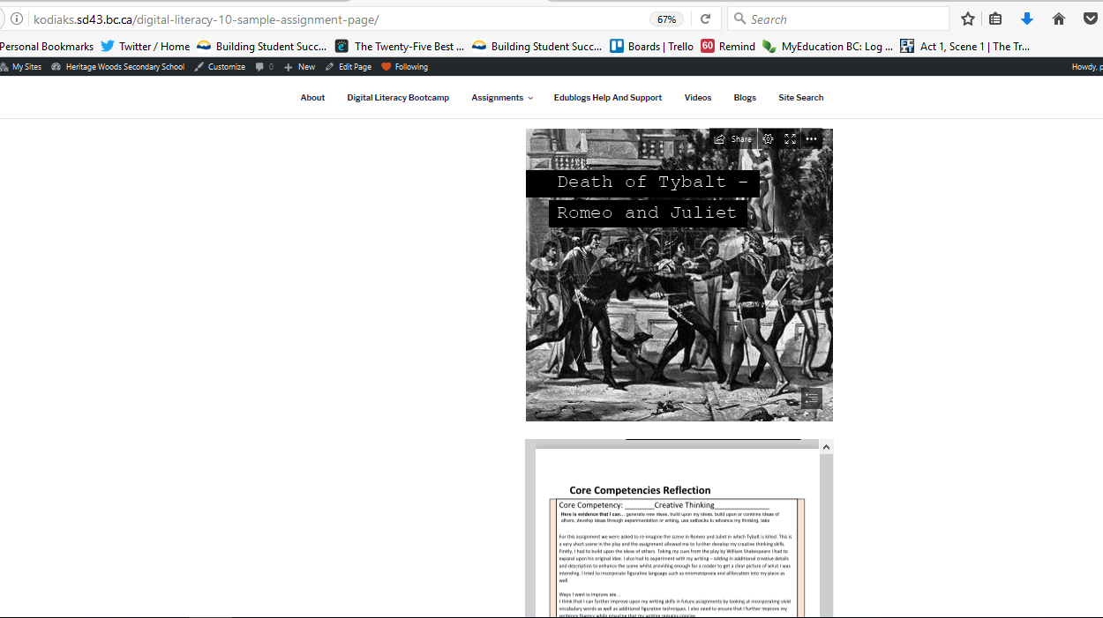.
The assignment/content is posted first – all Sways, PowerPoints, Word Documents, etc. should be embedded.
Following this is the reflection (downloaded) from the website – added by using the ‘Add Document’ plugin.

Adding Comments to Your Blog
You will need to ensure that all of the assignment pages that you create for Digital Literacy have the comment section enabled. This is the way in which Mr. Aitken and Mr. Castonguay will provide you with feedback on your assignments.
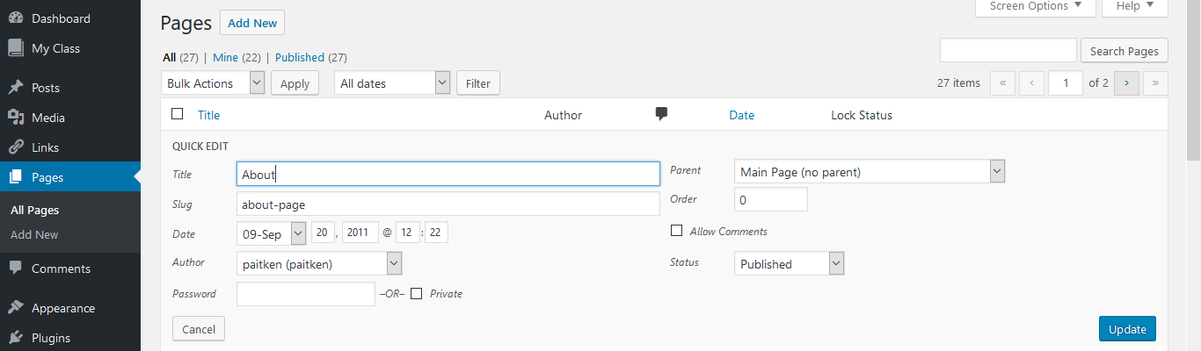
To add comments to any page you will need to go to your “Pages” screen.
On your Pages screen hover your cursor over the page that you would like to add comments to. A menu will appear below the specific page.
Select the “Quick Edit” option from the list of four choices.

A small menu will then pop up.
Select the Allow Comments option on the pop up menu.
Click ‘update’ to ensure that your changes are saved. You are now ready to receive comments on your page.
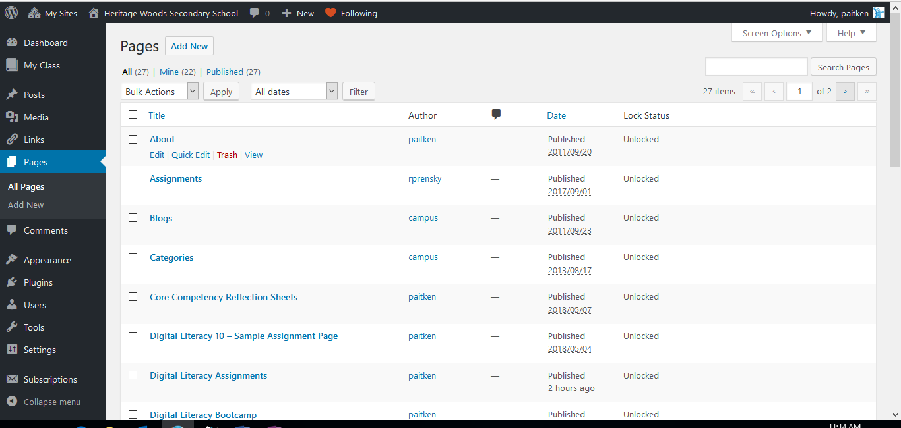

When your comments are enabled and Mr. Aitken or Mr. Castonguay has left a comment on your blog you will see something similar to this. You are then free to update your assignment based on the feedback that you have received.

