Digital Literacy 10 Mr. Aitken & Mr. Castonguay

Digital Literacy Bootcamp Basics
Using Menu’s

Menu’s, they are useful when you are ordering at a restaurant and also when you are trying to organize your blogs. You will find that, when you have logged into your blog, there is already a menu structure established for you. We have included your core grade nine subjects as well as for Digital Literacy, your Core Competencies and future courses at Heritage Woods. It is important to learn how to maintain your menu structure and add new pages to your menu’s.

Adding Pages To Your Blog
As you complete each of the assignment you will be adding them to your various course pages (Science, Socials, English etc.). When you add a lot of content to your page it can get confusing. The instructions below will demonstrate a way to keep your content organized and neatly presented.
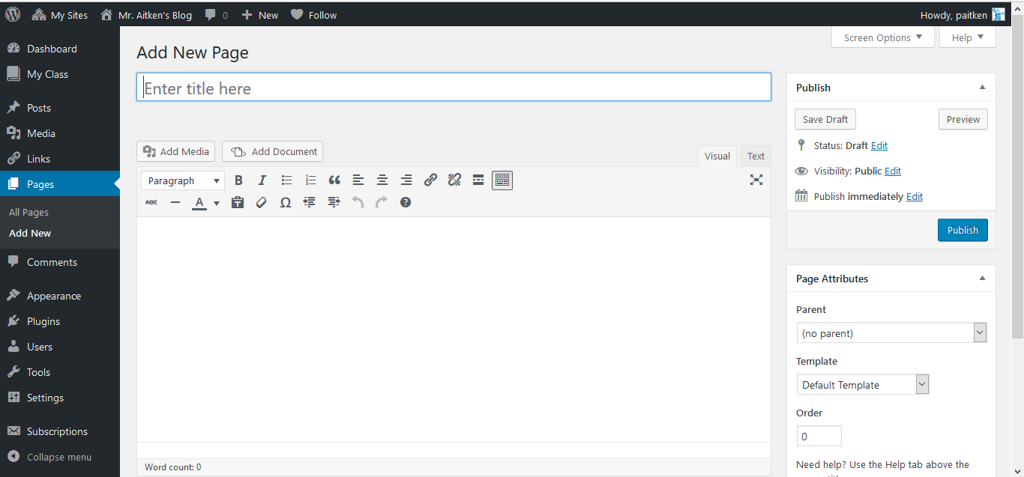
Whenever you start a new assignment you will need to create a NEW PAGE. Give your page a title and ensure that you hit the publish button to publish your page. You can come back and add your content later.
Select the New button at the top of the page and choose the New Page option.
You can then give your page a title – try creating one for your ‘Digital Footprint Assignment’
Publish your page – you can add content later.
Once the page is published select the View Page option that appears.

Adding Pages to Your Menu

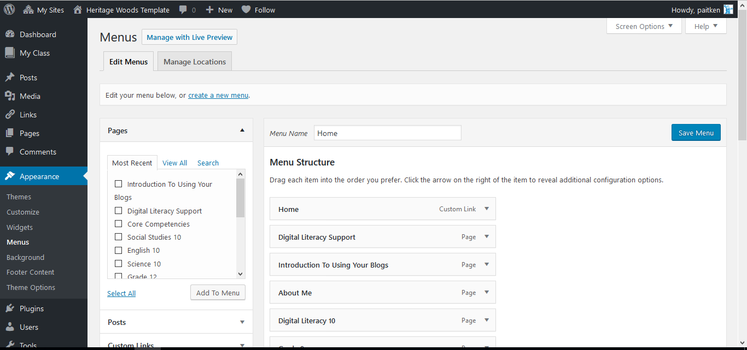
Your menu can be found on your dashboard under the Appearances tab. Clicking on that will bring up the page below. This is your menu. Moving items around on your menu is as simple as dragging and dropping them into the location that you would like to. If you would like to create drop-down menu’s you merely need to drag and drop items below one another so that they show up as “Sub-Menu” items.
Dragging Menu Items under one another will allow you to create drop -down menu’s under the original menu item.
In this case your grade nine courses become a drop-down menu under the original Grade Nine menu
Clicking on Appearance and Menu’s will bring up the Menu Page.
All of your pages are displayed in the menu on the left side of the page. Ensure that the box is selected and then click add to menu. Pages are added to the bottom of the list that appears in the middle of the screen.
Drag and drop items around your menu to arrange them as you wish. Click Save Menu to save your changes.
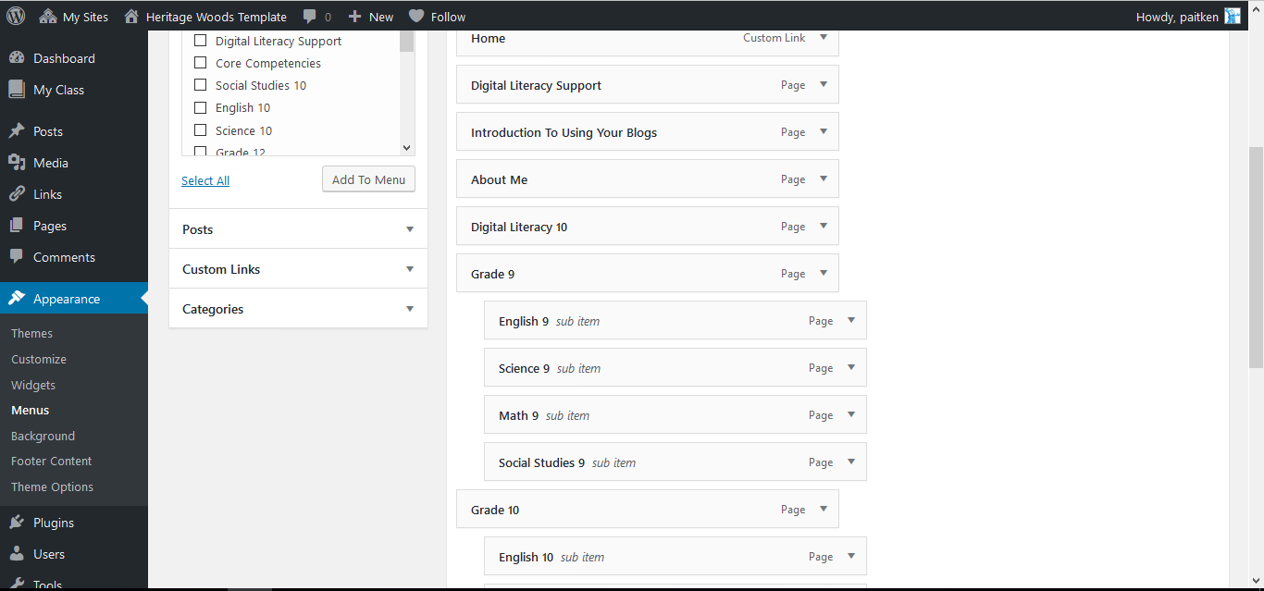

Linking Your Assignment Pages to Your Course Pages

While creating drop down menu’s for your assignments is acceptable – we will be checking your individual Socials, English and Science 9 pages. You will need to ensure that you create links to your assignments on these pages. The instructions for doing this are outlined on the document entitled Posts Vs. Pages. A brief synopsis of how to add links for your individual assignments is below.
As you complete each of the assignment you will be adding them to your various course pages (Science, Socials, English etc.). When you add a lot of content to your page it can get confusing. The instructions below will demonstrate a way to keep your content organized and neatly presented.
Whenever you start a new assignment you will need to create a NEW PAGE. Give your page a title and ensure that you hit the publish button to publish your page. You can come back and add your content later.
Select the New button at the top of the page and choose the New Page option.
You can then give your page a title – try creating one for your ‘Digital Footprint Assignment’
Publish your page – you can add content later.
Once the page is published select the View Page option that appears.

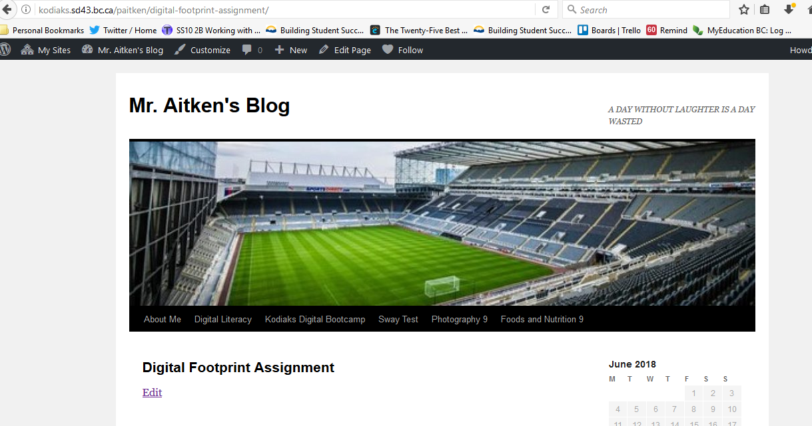
Once you have published your page you will need to select the View Page option. This will bring you to your newly created page. Ensure that you copy the URL of your newly created page. You will need it for the next step.
Copy the URL of your newly created Page.
You will then need to navigate to your Course page. If you are doing your Digital Footprint Assignment this will mean that you need to go to your Digital Literacy 10 page.

Navigate to the course page where you will be adding the assignment. If you are doing your Digital Footprint Assignment this will mean that you need to go to your Digital Literacy 10 page. You will need to select the Edit Page option. This will bring you to the editing page where you will paste your copied URL into your page. This will create a link within your blog – it will look like a small box. The title and the first lines of your content (if any) will be visible. Update that page and you will have successfully added/linked an assignment to your blog.
When you insert the URL from the assignment page, into the course page, it will create a link – in the form of a box. This will be displayed on your course page and will ensure that your blog remains neat and uncluttered to those who wish to view it.
Once you have entered the link be sure to update your page.
